Application to Vary from Public Health Order Requirements
- Business/Organization’s Name
Click here to enter text.

- Business Type
Click here to enter text.

- Business Address
Click here to enter text.

- Name of Primary Contact
Click here to enter text.

- Phone Number
Click here to enter text.

- Email
Click here to enter text.

- Floor Plan (attach visual showing hallways, washrooms, seating arrangements, etc.)
- On floor plan identify traffic flow (see example)
Dimensions of Space
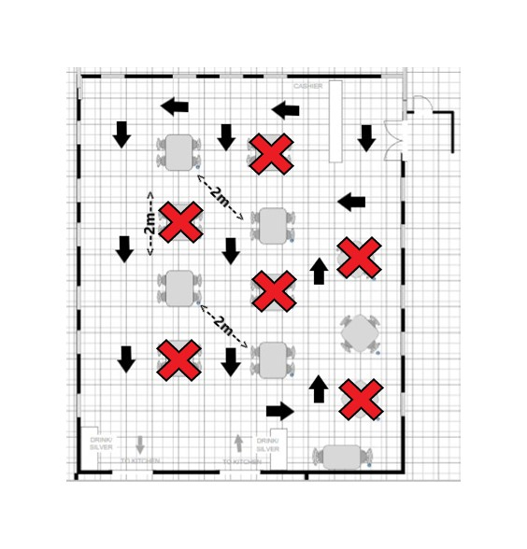
Click here to enter text.

Other spatial details of relevance
Click here to enter text.

Please note – floor plans can be hand drawn as necessary**
- Proposed mitigation/adaptation controls
Click here to enter text.

- Proposed Enhanced Cleaning procedures

- Bathroom procedures ( access and use, cleaning schedule etc)
Click here to enter text.

- Additional Information (if required)
Click here to enter text.

Submit to protectNWT@gov.nt.ca with the subject line ATTN: Request to Vary from Public Health Order.
Floor Plan

